

# Subscriber :

Mr PARAS JAIN

# Invoice No.:

**Date:**

MH06743624

02/08/2023 11:36

# Customer ID:

C2100552033

**Place of Supply:** Maharashtra

**Address:** 305,Floor-3,Tower-C2,Kingsbury,Charholi

Budruk,Pride World City

**State with PIN:** Maharashtra-412105

# Landline Number : PAN No :

**GSTIN :Address:** 3rd Floor, Unit 306,, Windsor, Off C.S.T.

road, Kalina,, Santacruz East,Mumbai

City,

# State Code: 27

**TPBB GSTIN:** 27AAACQ3943P1ZX

|  |  |  |  |  |  |  |  |
| --- | --- | --- | --- | --- | --- | --- | --- |
| Sr. No. | HSN / SAC | Description of Goods / Description of services | | | Base Amount | Discount Amount | Total Amount |
| 1 | 998422 | Internet Access Services | | | INR 1,050.00 | INR 0.00 | INR 1,239.00 |
| **SUMMARY OF CHARGES**  Base Amount Tax Amount CGST @9%  SGST/UTGST @9% IGST @0%  Amount in words | | | :  :  :  :  :  : | **AMOUNT**  INR 1,050.00  INR 189.00  INR 94.50  INR 94.50  INR 0.00  Rupees One Thousand Two Hundred Thirty Nine and Zero Paise only. | | |  |

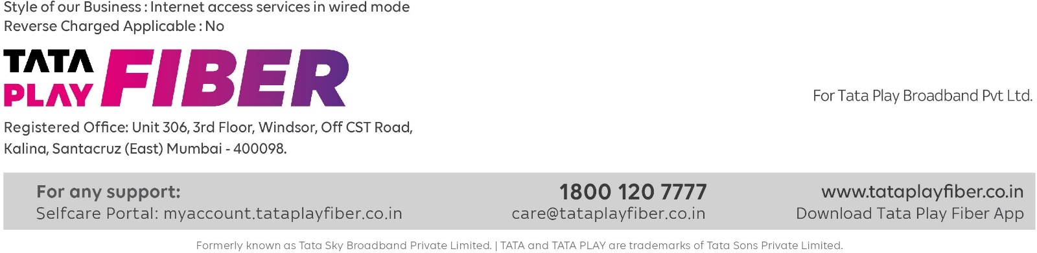

Signature Not Verified

Digitally signed by DS M/s TATA PLAY BROADBAND PRIVATE LIMITED 01

Date: 2023.09.03 21:43:45 IST